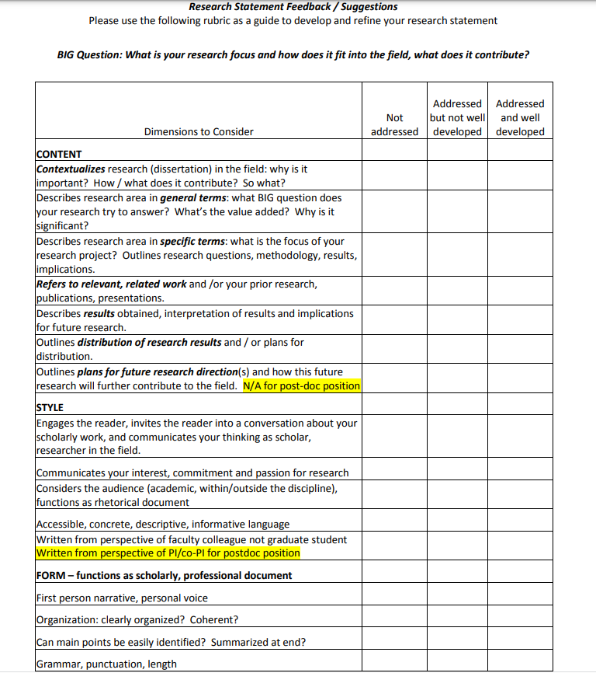
Developed by Gabriele Bauer, Ph.D., Center for Teaching & Learning, University of Delaware, 2011; gabriele@udel.edu

