**CV Quick Checklist**

“CV writing is […] about anticipating your selectors' needs and trying to make their lives as easy as possible.”   
 *Steve Joy, PhD, University of Cambridge*

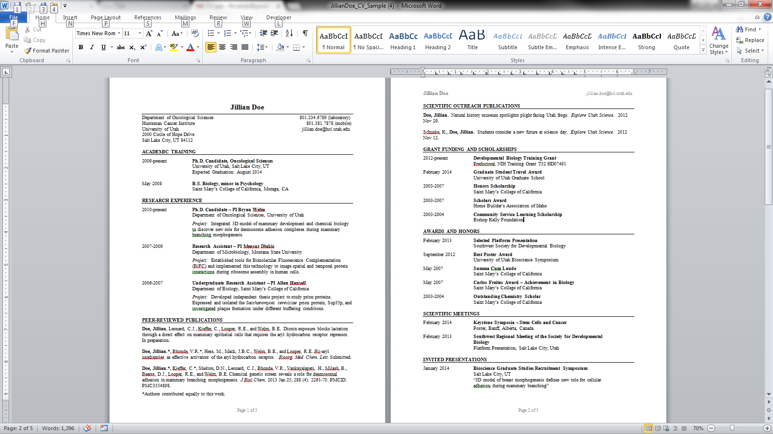

***At a Glance***

* **CV draws the eye in and is easy to read**
* **Visual organization is clear, and logical for the position sought:** features white space, bullets, bold/italics, etc., neither overused or underused)
* **Information most important/relevant to particular evaluators is easy to see, on first page**
* **All degrees and positions are listed in reverse chronological order**
* **Header on each subsequent page with name   
  and page number**

***Header***

* **Name is a larger font** than all the rest
* **All needed contact information there?**  Best phone number and email to reach you, departmental address, personal website, LinkedIn, etc.)
* **No unnecessary personal information**: In the US, employers are not allowed to consider  
  age, ethnic identity, political or religious affiliation, marital status, sexual orientation, place of birth, height, weight, health, or photographs.

***Typical Sections (can include more)***

* **Education:** Includes degrees, thesis title, month/year of graduation, and institution name and location.
* **Research Interests** (if applying for research positions)
* **Research Experience:** You can lead with your Postdoc position here.

For each research position, list your advisor,andinclude findings and methods. You can also note collaborations, as well as resulting publications and funding sources.

*All Experience sections can show your* accomplishments*, which distinguish you as a candidate.****See the table*** *on p. 2 above for sample impact verbs to build* ***accomplishment statements****.*

* **Research Grants:** Indicates your contributions to funded research and to grants under submission, as evidence of your grant-writing experience. Funding amounts are indicated, if customary in your field.
* **Teaching Experience:** Includes course titles, but not course codes. Show this section first if applying for a teaching position: expand with accomplishments, materials designed, effective student engagement approaches, etc.
* **Administrative Experience** if you have had such roles, and the particular position calls for such skills.
* **Mentoring Experience:** Name and affiliation of each student, and current status (which can be an indication of your success as a mentor)
* **Memberships and Affiliations**
* **Honors & Awards**
* **Service & Outreach:** This section can showcase skills such as initiative, leadership, communication, organizing, and collaboration.
* **Presentations/Poster Sessions**
* **Publications/Patents** (can be on first page or last page)
  + Status of papers not yet published is clearly indicated (e.g., Submitted, Under Review, Patent Pending, etc.).
  + Publications are consistently listed in the correct style for your field.
* **References*.*** Includes name, position, and both email and phone contact information for each reference.

**Keep in mind:** Your goal as a candidate is to submit a CV that demonstrates the experience, skills and qualities most relevant to the position and institution/department to which you are applying.

If you are a research-faculty candidate, the evaluators are looking for evidence of good **reputation, productivity, fundability,** and **fit** in your CV.

***For more detailed comments on this kind of CV:*** *see UCSF’s* [*Annotated Sample 4-page CV*](https://career.ucsf.edu/sites/g/files/tkssra2771/f/wysiwyg/SampleCVAnnotatedUCSFOCPD.pdf)*.*

***Finally…***

* **Update your CV regularly,** and show the latest date.
* **Proofread mercilessly** and ask others to look it over:errors affect your credibility!