Minutes
U of U Postdoctoral Association Board Meeting
4-5 pm on October 6th, 2021
Virtual meeting

Active Board Member Count: 11

Board members:

Elizabeth Charron (Epidemiology) - Jr. Chair
Elizabeth Sefton (Human Genetics) - Jr. Chair
Kenneth Lyon (Neurobiology and Anatomy)
Kristen Davenport (Biochemistry, Human Genetics)
Harriet Dashnow (Human Genetics) - Sr. Chair
Mai Tran (Biology, Human Genetics)
Noemi Paguiguan (Medicinal Chemistry)
Olja Simoska (Chemistry) - Secretary/treasurer
Sharanya Kalasekar (HCI)
Shraddha Nayak (Biochemistry)
Amy Barrios (OPA)
Leave of absence: Tosifa Memon (Pharmacology and Toxicology), Marta Iversen (Radiology) - Diversity and inclusion ??

Number Present: 13
Present: Mai Tran, Elizabeth Sefton, Elizabeth Charron, Kristen Davenport, Harriet Dashnow, Kenneth Lyon, Amy Barrios, Shraddha Nayak
Known Absences: Olja Simoska??
Absences: Noemi Paguiguan, Sharanya Kalasekar
Guests: Osiris Martinez-Guzman, Aldo E. Garcia-Guerrero, Sara Wong, Kevin M. Korous, Matthias Lange
Minutes taken by: Shraddha Nayak

Agenda

Introductions:
4 new attendees - Osiris Martinez-Guzman, Aldo E. Garcia-Guerrero, Sara Wong - all from Biochemistry; Kevin M. Korous (2-time attendee?) from Department of Family and Preventative Medicine

Old business
1) Minutes from September 2021/09/ 01: Approved
8 approvals and 1 abstention. (Shraddha made a mistake by approving, she was absent previously)

2) Grant Writing Events (from Kristen and Harriet)
> Recent Event: Discussion with Program Officer from NIH (held 3 weeks ago)- PO gave overview of tips for submission/ was engaging - answered Q’s frankly - well attended and was opened up to grad students
> Peer writing group sessions: Mai, Harriet and another person attended - Less engagement noted - peer feedback for grants was good but not a huge amount of enthusiasm b’cos deadlines are not lining up for everyone.
> To Do: Event to see what happens in a Review Panel (Mock Review) - Issue is we may not get enough grants to review - Harriet will take help from Amy to tailor input; But people are eager to know how the NIH scores work - it will be beneficial for postdocs to know what those numbers mean.

3) NPAW (20-24th Sept) summary (from Betsy)
> Good attendance for Keynote, CV/headshots and Social
> Low attendance, but good and focused participation for flash talk and poster workshop, so small groups worked well - Carolyn was great at her job, with her exercises very helpful to participants.
> To Do: Betsy will send a testimonial for Carolyn and ask Board to check.

Feedback for Future:
> Good to be virtual for certain events - a hybrid event may work well. In-person socials also work well amongst other virtual events.
> Attendance is still an issue - ppl not showing up after signing up - Embarrassing for big ppl who put energy and time for such events/ workshops, so considering an internal person may be useful; rethinking longer workshops and topics to address.
> Headshots needs to be done yearly or every other year as it’s very popular
> A survey can be run beforehand to ask the community what they’d like to see.
> Osiris did not want to go in person due to Covid and enjoyed all the virtual sessions
> NPAW was a success since we followed University rules and nothing embarrassing happened at our events (no super-spreaders)
> Rethink ways to advertise and invite participants - Sara says Live tweeting about events to generate more excitement and interest.

New business
1) Late Oct/ Early Nov: Finding a Scientific Society (Mai)
- Testing a hybrid event (in person and having the Owl cam)
- Mai will reach out to panelists and fix an ad soon
- Ken will be asked to request Paul Jeffry for Owl scheduling and fix a suitable day/time for event

2) Nov: Emotional Intelligence (Ken/ Betsy)
- Ken is thinking of Trinh through Kristen
- But Amy will send an email to someone at the Wellness Center to get a quick response and a suitable person.
- Betsy will work with Rick to schedule a room OR Ken will be asked to request Paul Jeffry for Owl scheduling and fix a suitable day/time for event

3) Dec: Grant Event - PI panel Q&A (Harriet)

4) Jan: Job/ Chalk Talk (Betsy)
- Mai said she reached out to Nels? (Check this)

5) Feb: Visas/Immigration/Green Cards (Mai)
- Harriet advises to reach out soon and give that speaker at least a 2-mo notice

6) March: Procrastination (Liz will take lead)

7) April: Designing Your Brand

8) May: Implicit Bias/ Gender Inclusivity/ Social Justice/ DEI (Kevin will take lead)

9) June: Postdoc rights/ responsibilities -
Amy says the doc has been drafted and process will be finished by the end of the academic year (Summer 2022)

10) July: Academic/ Industry Job Panel

Suggestions for events:
- Event dates/ occurrence not set in stone, events can be moved around, and if no enthusiasm to organize can be scraped for something else.
- Take opportunity to organize what we are excited or passionate about.
- Event to benefit Utah grad students (from a postdoc POV) (Kevin) - How to find a postdoc? Mentoring Grad Students - Connect with CaDeTS to check if something like this is beneficial to them. Kristen will provide CaDeTS contact.
- Scientific Reproducibility

Social Event (Ken):
Oct 17th (Sun): Hike in Mill Creek Church Fork - Sunday cos dogs are allowed - Brunch nearby after that - carpooling plans
- Feedback: Church Fork is a busy trailhead
- Betsy will help with hiking trail suggestions.

Call for Inclusion and Diversity Officer:
- Kevin is interested/volunteering. Yay!
- Martha left as Inclusion and Diversity Officer since she’s moved onto a new job
- Work will be to reach out to other sister/ local/ national organizations and make sure we have diversity in our events.

Budget:
Amy suggests we can set a budget for every year so the PDO is prepared and can plan for expenses; Amy shared a spreadsheet to show how much we can spend; Suggested to have a Treasurer.
- Accountability for the budget will be good and we can spend more on food due to awareness of fat budget.
- Plan for now: Be prompt about getting receipts in place and submitted to Rick Solis, who has a tab on all expenses and Amy will share the Google spreadsheet with the Board, so ppl can plan and log in expenses
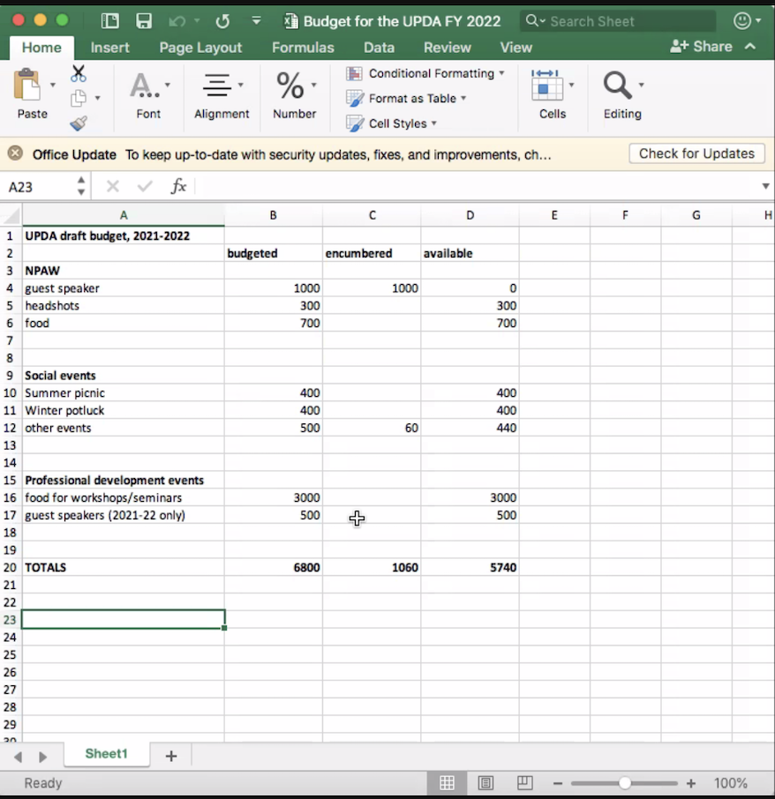

Website Update (Betsy/Kevin):
- Meeting minutes is up as it was tough to get rid of that page and website layout got screwed?
- Home Page info is off - Board Meeting info is off - Have info in one place only instead of multiple places.

Farewells:
- Kristen is leaving in 2 weeks and Shraddha in 8 weeks
- Farewell event on Nov 13th Saturday via Slack votes - Brunch at Kristen’s place.

Recruitment:
- Kristen, Harriet and Shraddha working on this in the next couple weeks.

Recording Seminars:
- Will run a pilot with first few events to see response - Owl will help record, so technically easy
- Only for events that seem reasonable to be recorded and the speakers have given consent
- Ppl don’t want to be recorded or noticed by their PIs - a hypothetical situation to be overridden
- Recording seminars may cause low attendance as ppl will put off for later/ watch recording
- Speakers will not be comfortable being honest or giving personal opinions
- Kevin’s suggestion: register to get recording policy.
- Sara: Her grad school maintained a YouTube channel with couple hundred views - easiest way to share and make access public or private.
- Reach out to peer postdoc groups to find out how their experiences have been with recording.

